**PIZZA SALES SQL QUERIES**

1. **KPI’s**

1. **Total Revenue:**

**SELECT SUM(total_price) as total_revenue**

**FROM pizza_sales**

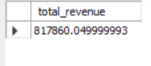

1. **Average Order Value:**

**SELECT AVG(total_price) AS avg_order_value**

**FROM(**

**SELECT order_id, SUM(total_price) as total_price**

**FROM pizza_sales**

**GROUP BY order_id**

**) A**

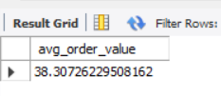

1. **Total Pizza Sold:**

**SELECT SUM(quantity) as total_quantity**

**FROM pizza_sales**

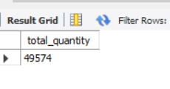

1. **Total Orders:**

**SELECT COUNT(DISTINCT order_id) as total_orders**

**FROM pizza_sales ;**

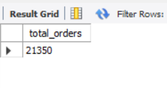

1. **Average Pizzas Per Order:**

**SELECT SUM(quantity)/ COUNT(DISTINCT order_id) AS avg_pizzas_per_order**

**FROM pizza_sales**

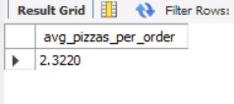

1. **Hourly Trend For Total Pizzas Sold:**

**SELECT HOUR(order_time) as order_hours,**

**SUM(quantity) as total_pizzas_sold**

**FROM pizza_sales**

**GROUP BY HOUR(order_time)**

**ORDER BY order_hours ASC**

**OUTPUT –**

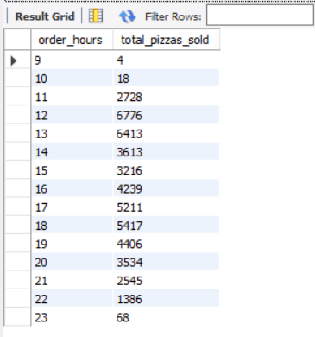

1. **Weekly Trend For Orders:**

**SELECT WEEK(order_date) as WeekNumber ,**

**YEAR(order_date) as Year ,**

**COUNT(DISTINCT order_id) as Total_orders**

**FROM pizza_sales**

**GROUP BY WEEK (order_date),YEAR(order_date) ;**

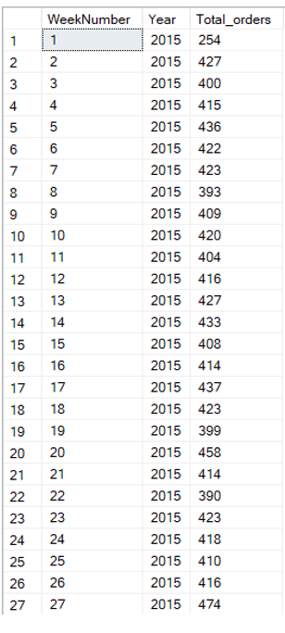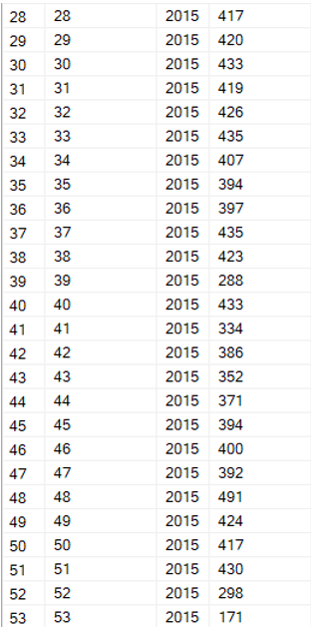

1. **% of Sales by Pizza’s Category:**

**SELECT pizza_category,SUM(total_price) as total_revenue,**

**ROUND(100.0*SUM(total_price)/(SELECT SUM(total_price) FROM pizza_sales),2) AS PCT**

**FROM pizza_sales**

**GROUP BY pizza_category**

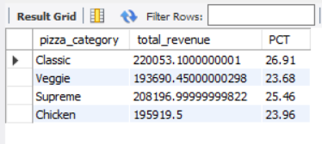

1. **% of Sales by Pizza’s Size:**

**SELECT pizza_size, SUM(total_price) as total_revenue,**

**ROUND(100.0*SUM(total_price)/(SELECT SUM(total_price) FROM pizza_sales),2) AS PCT**

**FROM pizza_sales**

**GROUP BY pizza_size**

**ORDER BY PCT DESC**

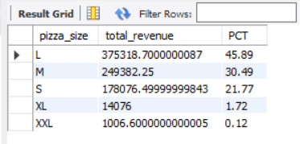

1. **Total Pizzas Sold by Pizza Category:**

**SELECT pizza_category , SUM(quantity) as total_quantity_sold**

**FROM pizza_sales**

**GROUP BY pizza_category**

**ORDER BY total_quantity_sold DESC**

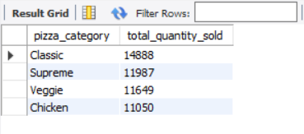

1. **Top 5 Pizzas by Revenue:**

**SELECT pizza_name, SUM(total_price) as total_revenue**

**FROM pizza_sales**

**GROUP BY pizza_name**

**ORDER BY total_revenue DESC**

**LIMIT 5;**

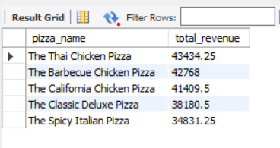

1. **Bottom 5 Pizzas by Revenue:**

**SELECT pizza_name , SUM(total_price) as total_revenue**

**FROM pizza_sales**

**GROUP BY pizza_name**

**ORDER BY total_revenue ASC**

**LIMIT 5**

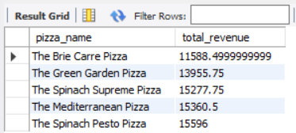

1. **Top 5 Pizzas by Quantity :**

**SELECT pizza_name , SUM(quantity) as total_quantity**

**FROM pizza_sales**

**GROUP BY pizza_name**

**ORDER BY total_quantity DESC**

**LIMIT 5;**

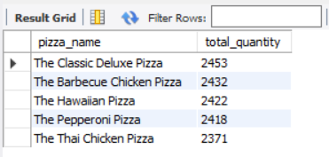

1. **Bottom 5 Pizzas by Quantity :**

**SELECT pizza_name , SUM(quantity)as total_quantity**

**FROM pizza_sales**

**GROUP BY pizza_name**

**ORDER BY total_quantity ASC**

**LIMIT 5**

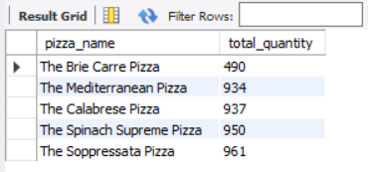

1. **Top 5 Pizzas by Total Orders :**

**SELECT pizza_name , COUNT(DISTINCT order_id) as total_orders**

**FROM pizza_sales**

**GROUP BY pizza_name**

**ORDER BY total_orders DESC**

**LIMIT 5 ;**

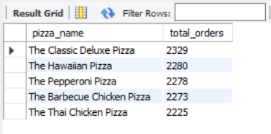

1. **Bottom 5 Pizzas by Total Orders :**

**SELECT pizza_name , COUNT(DISTINCT order_id) as total_orders**

**FROM pizza_sales**

**GROUP BY pizza_name**

**ORDER BY total_orders asc**

**LIMIT 5 ;**

